**CAPSTONE PROJECT**

**Project: Health care Data Analysis**

**CITY Report:**

**Data Ingestion:**

**Step1:**

hdfs dfs -mkdir -p prescpipeline/staging/city

hdfs dfs -put us_cities_dimension.parquet prescpipeline/staging/city

**Step2:**

cityDF=spark.read.option("header",True).option("inferschema",True).parquet('prescpipeline/staging/city/us_cities_dimension.parquet')

cityDF.printSchema()

cityDF.show(10)

**cityDF.count()**

**Data Cleansing/Preprocessing:**

**Step1: Selecting the required columns**

cityDF1=cityDF.select('city','state_id','state_name','county_name','population','zips')

cityDF1.show(4)

cityDF1.printSchema()

**Step2: Converting the required fields to upper case**

import pyspark.sql.functions as F

cityDF2=cityDF1.select(F.upper(cityDF1.city).alias("city"),'state_id',F.upper(cityDF1.state_name).alias("state_name"),F.upper(cityDF1.county_name).alias("county_name"),'population','zips')

cityDF2.show(3)

**Transform Logic: City Report**

**1.Calculate the Number of zips in each city.**

from pyspark.sql.functions import col, lit

from pyspark.sql.functions import split, explode , size

split_col=split(cityDF1['ZIPS'],' ')

df_split = cityDF1.withColumn('Zip_Split_cnt',size(split_col))

df_split.createOrReplaceTempView("City_split_df")

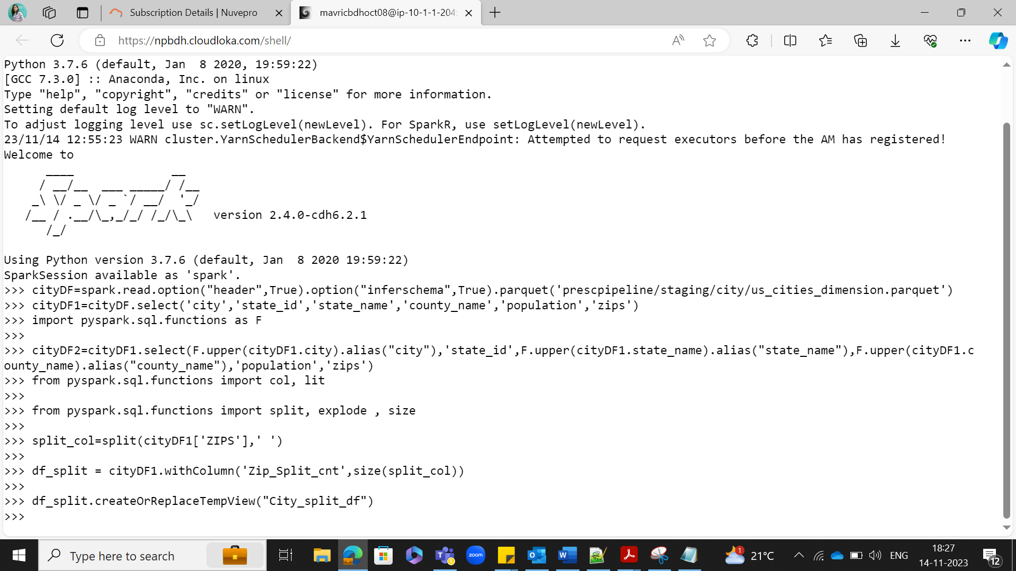

**2.Calculate the number of distinct Prescribers assigned for each City.**

prescriber1_df = spark.sql("SELECT count(distinct npi) as Prescriber_Counts,np_city from prescriber group by np_city").show()

**3.Calculate total_claim_count prescribed for each city.**

prescriber1_df = spark.sql("SELECT sum(tot_claim_cnt) as total_claim_counts, np_state from prescriber group by np_state") .show()

**4.Do not report a city in the final report if no prescriber is assigned to it.**

prescriber1_df.createOrReplaceTempView("prescriber1")

df_split.createOrReplaceTempView("City_split_df")

**spark.sql( "SELECT CITY as City_Name,STATE_NAME as State_Name,COUNTY_NAME as County_Name ,POPULATION as City_Population,Zip_Split_cnt as Number_of_Zips,p.Prescriber_Counts,p.total_claim_counts FROM City_split_df c inner join prescriber1 p on upper(c.CITY) = p.np_city and c.STATE_ID = p.np_state").show()**

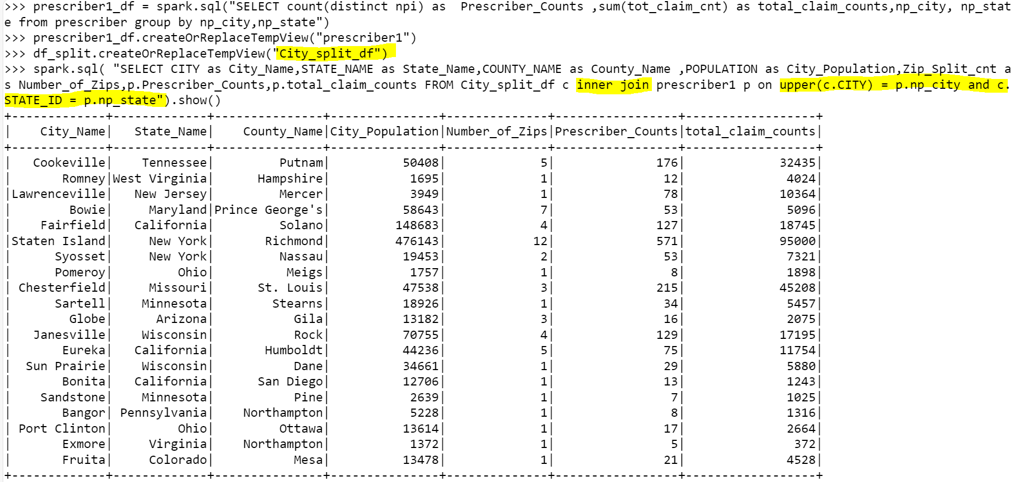

spark.sql( "SELECT CITY as City_Name,STATE_NAME as State_Name,COUNTY_NAME as County_Name ,POPULATION as City_Population,Zip_Split_cnt as Number_of_Zips,p.Prescriber_Counts,p.total_claim_counts FROM City_split_df c inner join prescriber1 p on upper(c.CITY) = p.np_city and c.STATE_ID = p.np_state where p.Prescriber_Counts != 0").show()

**Checking if any city having no prescriber :**

spark.sql( "SELECT CITY as City_Name,STATE_NAME as State_Name,COUNTY_NAME as County_Name ,POPULATION as City_Population,Zip_Split_cnt a

s Number_of_Zips,p.Prescriber_Counts,p.total_claim_counts FROM City_split_df c inner join prescriber1 p on upper(c.CITY) = p.np_city and c.

STATE_ID = p.np_state where p.Prescriber_Counts = 0").show()

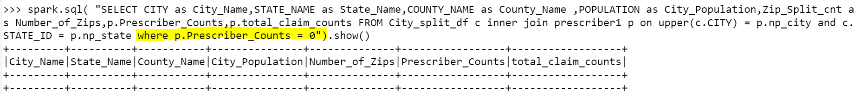

**Writing the City Report outputs in to Hive/HDFS:**

from pyspark.sql import SparkSession

spark=SparkSession.builder.appName("SparkHive").enableHiveSupport().config("spark.sql.warehouse.dir","/user/hive/warehouse").getOrCreate()

spark.sparkContext.setLogLevel("ERROR")

City_report_df = spark.sql( "SELECT CITY as City_Name,STATE_NAME as State_Name,COUNTY_NAME as County_Name ,POPULATION as City_Population,Zip_Split_cnt as Number_of_Zips,p.Prescriber_Counts,p.total_claim_counts FROM City_split_df c inner join prescriber1 p on upper(c.CITY) = p.np_city and c.STATE_ID = p.np_state where p.Prescriber_Counts != 0")

**No of splits: 1**

repart_df = prescriber_report_DF.repartition(1)

repart_df.write.mode("overwrite").option("compression","bzip2").json("/user/mavricbdhoct08/prescpipeline/output/city")



**City output In HDFS – 1 Split showing**

**Output City Report Layout**

No of splits: 1

Output format: JSON

Compression : Bzip2

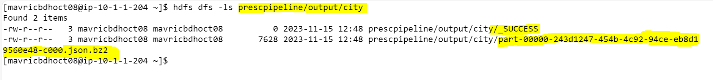

[mavricbdhoct08@ip-10-1-1-204 ~]$ hdfs dfs -ls prescpipeline/output/city

Found 2 items

-rw-r--r-- 3 mavricbdhoct08 mavricbdhoct08 0 2023-11-15 12:48 prescpipeline/output/city/_SUCCESS

-rw-r--r-- 3 mavricbdhoct08 mavricbdhoct08 7628 2023-11-15 12:48 prescpipeline/output/city/part-00000-243d1247-454b-4c92-94ce-eb8d1

9560e48-c000.json.bz2

[mavricbdhoct08@ip-10-1-1-204 ~]$

**City output In hive :**

City_report_df.write.mode("overwrite").saveAsTable("City_Final_Report")

**desc Final_City_Report;**

**Select * from City_Final_Report limit 10;**

**select count(*) from City_Final_Report;**

